URL | website-title-tags
Title | How to create Title Tags for SEO? [Guide]
Meta Description | Craft Website Title Tags that have a great Click-Through-Rate (CTR) and boost your Business in Search Engine Rankings
Headline | Website title tags and their impact on CTR and SEO
Reading Time | 14
Level | Intermediate
Category | SEO
Teaser | Title tags, Metas and Alt Tags are often mixed up. This article explains you all you must know about Tags to improve your SEO

Title Tags Explained: How to Create Title Tags for SEO

Crafting the perfect title tag is one of the most overlooked components of SEO. Most people just write an eye-catching title without thinking about how to optimize it for SEO and then begin to wonder why they’re not achieving as high of a click-through rate as they’d like.

It has been confirmed by Google that optimizing your title tags can “help a lot” with your SEO efforts:

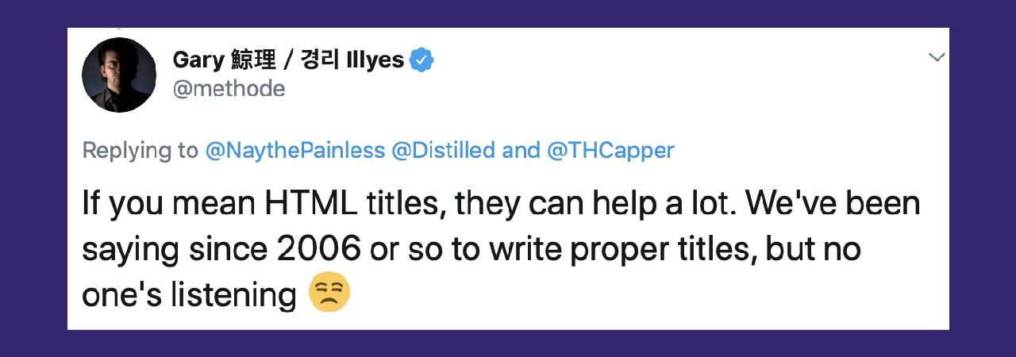
Abbildung 1 Importance of Title Tags

Title tags are arguably the most important on-page SEO factor, as they are the first, and sometimes the only opportunity you get to impress your target audience. They give search engines an overview of what information the web page is going to include, making it easier to crawl and index your web page.

Titles are also the most important factor in improving your clickthrough rate (CTR). The more people you can get clicking on your web page, the more traffic you will get, the more social shares you will have, the more backlinks you will gain and the more sales you will make. Before any conversion has to take place, the reader has to click on your title.

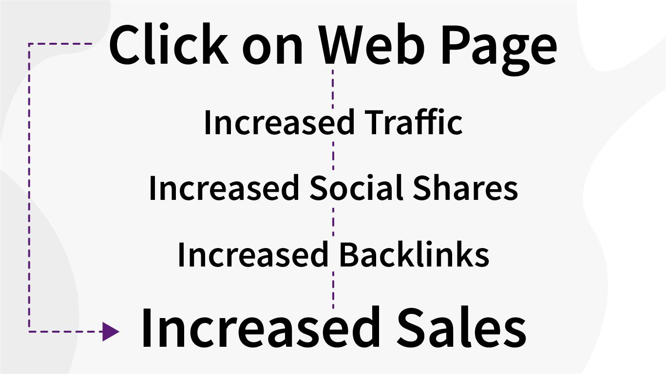
Abbildung 2 Impact of Title Tags on Click-Through-Rate (CTR)

This article will provide you with tips so you can select the perfect SEO title tag for all of your content.

What are Title Tags?

Title tags are the clickable link that you see on the search engine results pages (SERPs). They are HTML elements that allow search engines to view the title of the web page it is crawling.

Your title tag will be the first thing that both search engines and people view, which is why I said earlier it is arguably the most important part of your on-page SEO.

For example, if you Google ‘SEO’ in Google, this result from Wordstream is one of the top results:

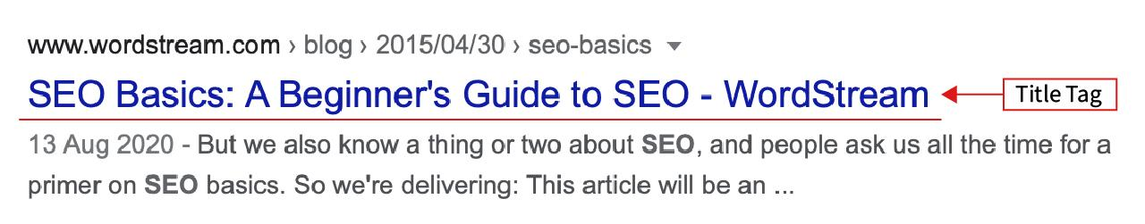
Abbildung 3 Title Tag Example

For this example, the title tag is ‘SEO Basics: A Beginners Guide to SEO’

This will be what both search engines and people will see when they find this web page in the search results.

In your tabbed browsers, the title tag will appear like this:


Abbildung 4 Title Tag Browser-View

Title Tags Do’s and Don'ts

Make it Eye-Catching
The important thing to remember about title tags is that you are writing them for both search engines and real people. If you perfectly optimize it for SEO but fail to make it appeal to people, your click-through rate will not be as high as it could be as people will skip past your web page.

If we look back at the example earlier from Wordstream, when you click into the article, you will see that the headline is different from the title tag:

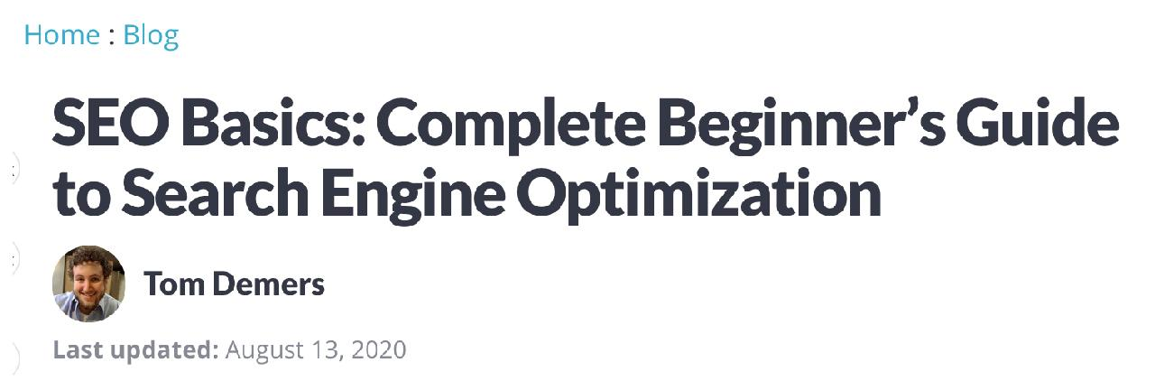
Abbildung 5 H1 Tag Example

This on-page title is known as an H1 tag and is different from the title tag. There are 6 different H tags you can include in your on-page content, from H1 (the most important) to H6 (the least important.

The reason Wordstream has a different title-tag and H1 tag is because the title-tag is shorter, more eye-catching, and therefore more likely to have a higher click-through rate.

The H1 tag can then have more ‘SEO juice’ as you can include more keywords than in your title tag. The key thing to remember about writing title tags is that you are primarily writing them for real people, not for search engines.

Make Sure Your Coding is Correct
In the HTML, your title should appear like this:
<title>This is a title</title>

And your H1 tag should appear like this:
<h1>This is a heading</h1>

Check your coding to make sure that your title tag and H1 tag appear in this format as this is how search engines will crawl them to figure out what your web page is about.

Make it More Than 15 Characters and Less Than 60 Characters Long
Generally, titles over 60 characters will cut off the title-tag with an ellipsis (...), which you want to try to avoid at all costs. The amount of characters shown in your title actually depends on the number of pixels it uses, so always follow the rule: shorter is better.

Shorter titles allow readers to get a full view of what your web page is about and are easier for them to read and for search engines to crawl. However, you don’t want it to be too short that it has poor readability.

Backlinko’s study found that “title tags between 15 and 40 characters have the best organic CTR. 8.6% better than characters outside this range”, which is similar to the findings of a study by Etsy, who found that “shorter title tags performed better than longer ones.”

Use this tool by Moz to preview what your title tag would look like in Google’s search results.

Use the Correct Punctuation
The main mistake people make with punctuation in their titles is either capitalizing all of their titles or not capitalizing it at all.

Instead, you want to capitalize the first and main words in your title. Also make sure to add exclamation marks, questions marks, hyphens, and brackets if they are applicable. This can help your content seem more articulate. After all, who would want to read an article that doesn’t even have a correct title?

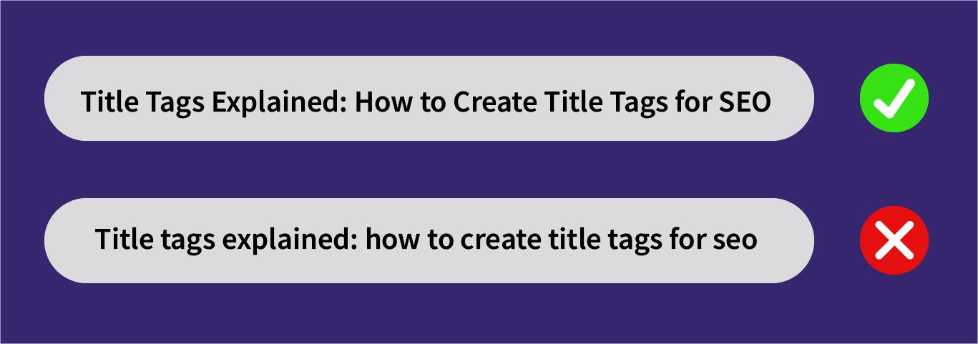
Abbildung 6 Title Tag Puctuation: How to use The correct Punctuation

A study by HubSpot and OutBrain found that using bracketed clarifications in headlines (e.g. [interview], [photos], [new guide], [video], etc.) can increase CTR by 33%.

Include Your Main Keyword
Since search engines use title-tags to figure out what a page’s content is about, it is good practice to include your main keyword in it. Your target audience is also much more likely to click on a result that exactly matches their search query.

Notice, how I only said: Include your main keyword. If you stuff too many keywords into your title, you will probably end up ranking for none of them. Instead, include the main keyword that you want to rank for at the beginning of your title tag (in the first 1-3 words). Most users won’t bother reading to the end of your title to see your keyword at the end. If they don’t see what they’re looking for, they will skip to the next title.

Include These Phrases
A study of 100 million titles by BuzzSumo found that these are the top 20 title phrases that result in the most social engagement:

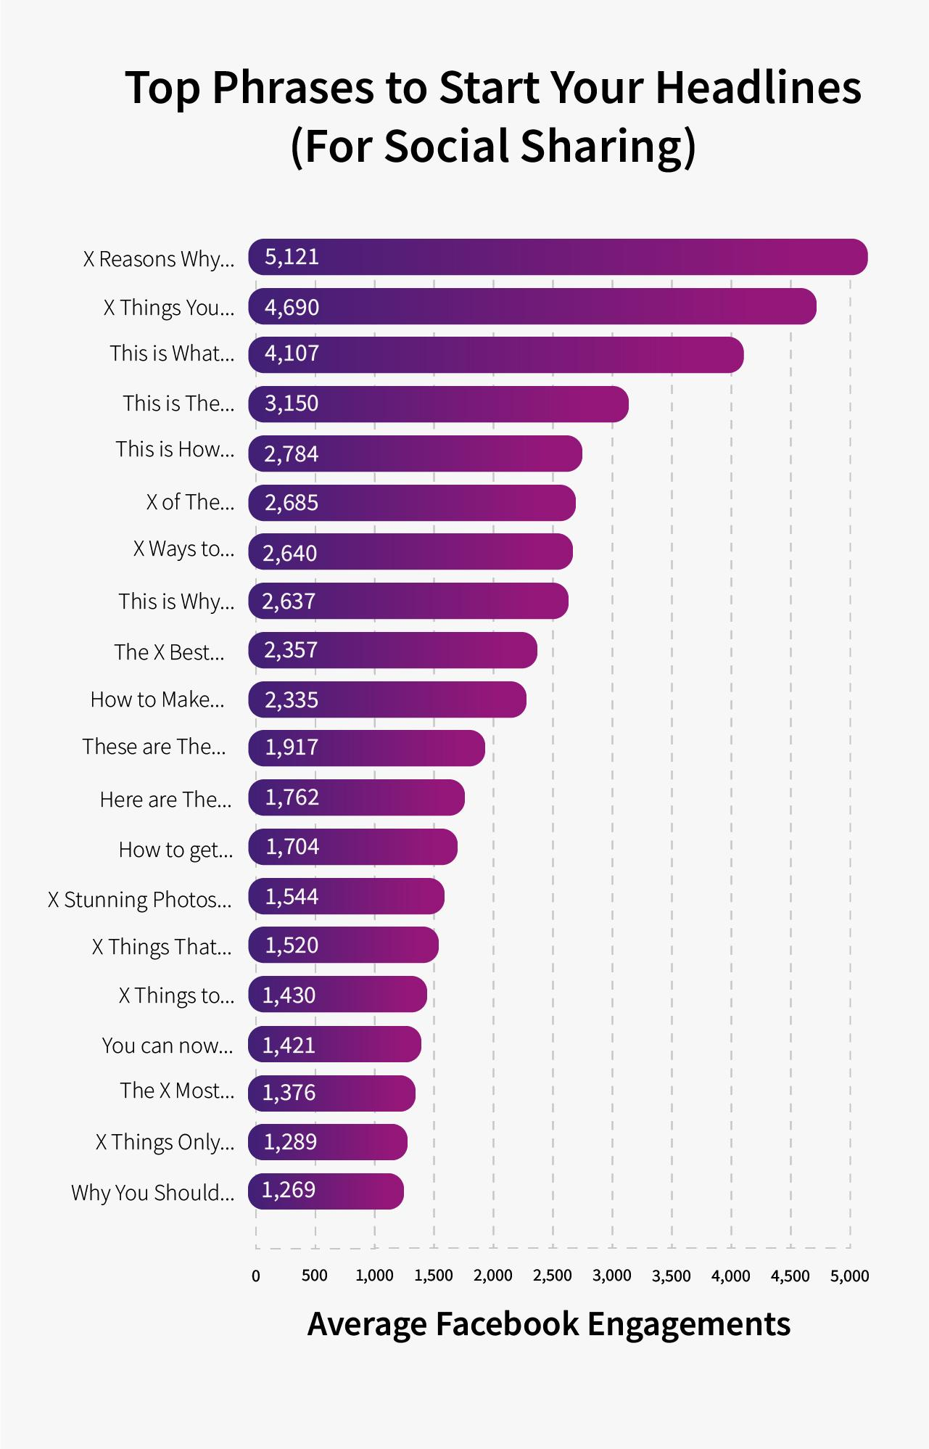
Abbildung 7 Top Headline Phrases
As I said earlier, the number one thing to remember about writing title tags is that you are writing them for people and not just for search engines. Any good copywriter knows that using emotive language and phrases can influence the behavior of users online.

Social shares are an indirect factor that affects your SEO ranking. Whilst search engines don’t use them to determine where to rank your content, increasing your social shares will mean more visibility, and probably more backlinks, which is one of the most important SEO ranking factors.

Make it Unique
Just as search engines do not like duplicate on-page content, they also don’t like duplicate title tags. Plus, why do you want a title tag that blends in with those you are competing with?

A good idea is to use one of the 20 phrases mentioned above to make your title stand out from the others.

Include a Call to Action (CTA)
Choosing the right keywords is important in all SEO strategies. When it comes to title tags, the words you put around your keyword can be just as important.

It sounds simple, but just by asking the users to complete a task can significantly increase your conversion rate. Try to use words such as learn, buy, subscribe, click, open, order, hire, etc.

Using these can help entice your reader to click on your title.

Ask Questions
A great alternative to using a call to action is to ask questions in your title.

After all, people are searching on search engines to find an answer to their queries. If you can include their question in your title, you can show the readers that you have the exact answer they are looking for and boost your CTR.

Backlinko conducted a study of 5 million search results and found that question titles have a 14.1% higher organic CTR than non-question titles.

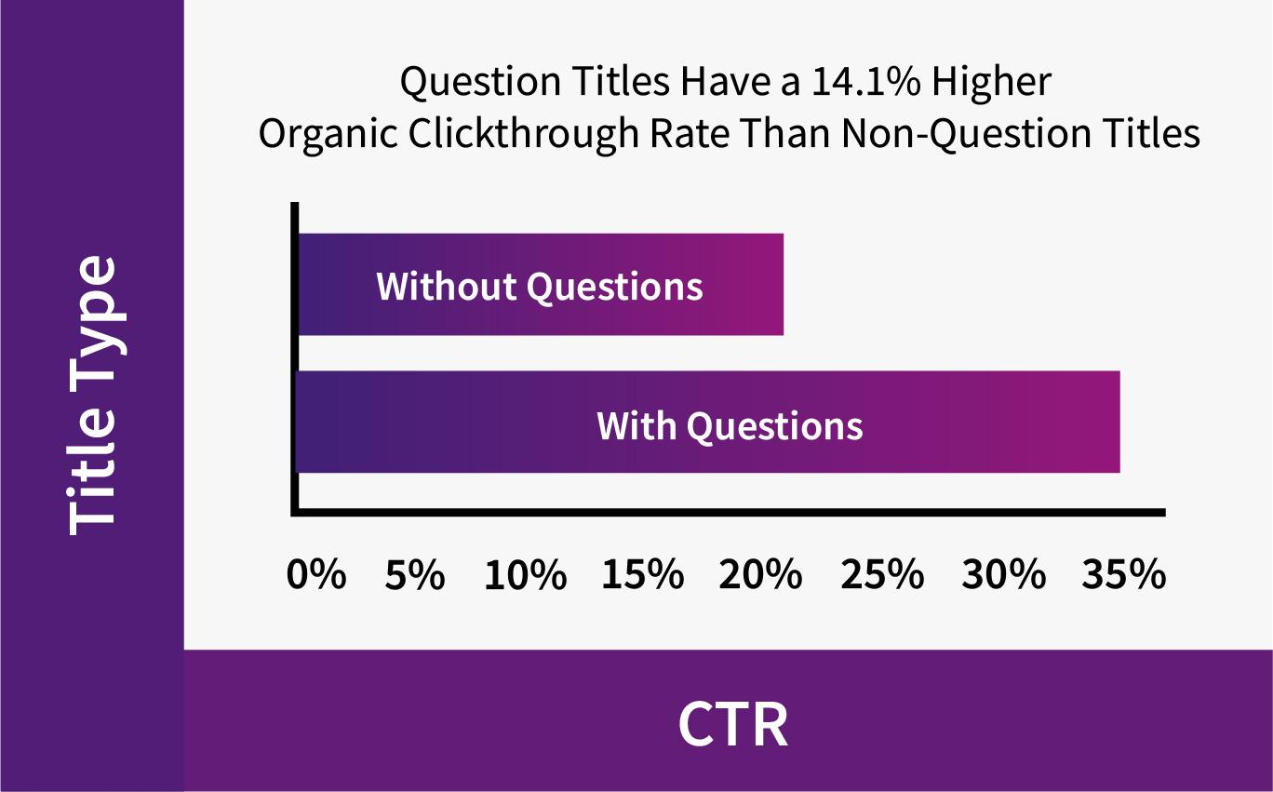
Abbildung 8 Titles with a good CTR

Use Title’s That Accurately Represent Page Content
Did you know that Google can reword your title tags? According to Silkstream, Google does this “if their algorithm is under the impression that the page title doesn’t accurately represent the content on that page.”
If Google doesn’t like your title tag, they may use other factors such as on-page text, anchor text, and structured data markup to rewrite their own title for your web page.

Google can also alter your title to better match different users' search queries. Whilst this can be unavoidable, there are some things you can do to try and avoid search engines from rewriting your titles.

Make sure your title matches what your web page is about and remember to write them for people as well as search engines. If you follow the steps in this article, you should be able to avoid Google rewording your titles.

Should You Use Emojis in Your Title Tags

In 2015, Google disabled the use of emojis in search results. Just one year later, they reversed this decision after seeing the growing popularity of them, being used by 92% of the online population.

In fact, 36% of millennials believe that “visual expressions” in the form of emojis or GIFs better communicate their thoughts and feelings than written words. This belief is shared with 25% of 35-64-year-olds, along with roughly 18% of over 65s.

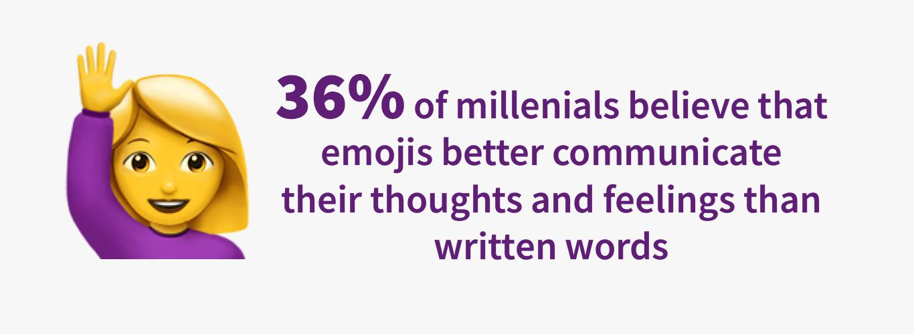
Abbildung 9 Title Tags with Emojis

Whilst emojis have traditionally been used for messaging and social media networking, many websites are beginning to utilize them as part of their SEO campaign, but how can they help?

Firstly, putting emojis in your title is an easy way to make your web page stand out from your other competitors on the SERPs.

They can also help with your business to reach a younger audience, as that is where they are most popular. The majority of under 35s extensively use emojis in everyday messaging on their phone, so they will be attracted to your web page if they see it in the search engine results.

How can the Use of Emojis Improve Ranking Position?

Because of what is mentioned above, the use of emojis can help your SEO campaign by increasing your click-through rate, which has a high correlation with the rank position.

It may not be a make or break factor in your SEO efforts, but it can give you a slight advantage when trying to outrank your competitors.

The key is to only use them when it is perfectly reasonable to do so. Use one in your title tag if it makes sense too, or maybe add one into your meta description instead. Because they are used to improve your clickthrough rate, you want them to be placed somewhere that users will be able to see them in the search results.

How to Generate Your Title Ideas
Now you know the do’s and don’ts of crafting title tags, how do you go about creating one?

1. Find Your Main and Long-Tail Keywords
Whilst the average number 1 ranking page ranks for 1,000 keywords, it’s not possible to include that many words in a single title tag. With your title tag, you should optimize for just your main keyword, and potentially a long-tail keyword as well.

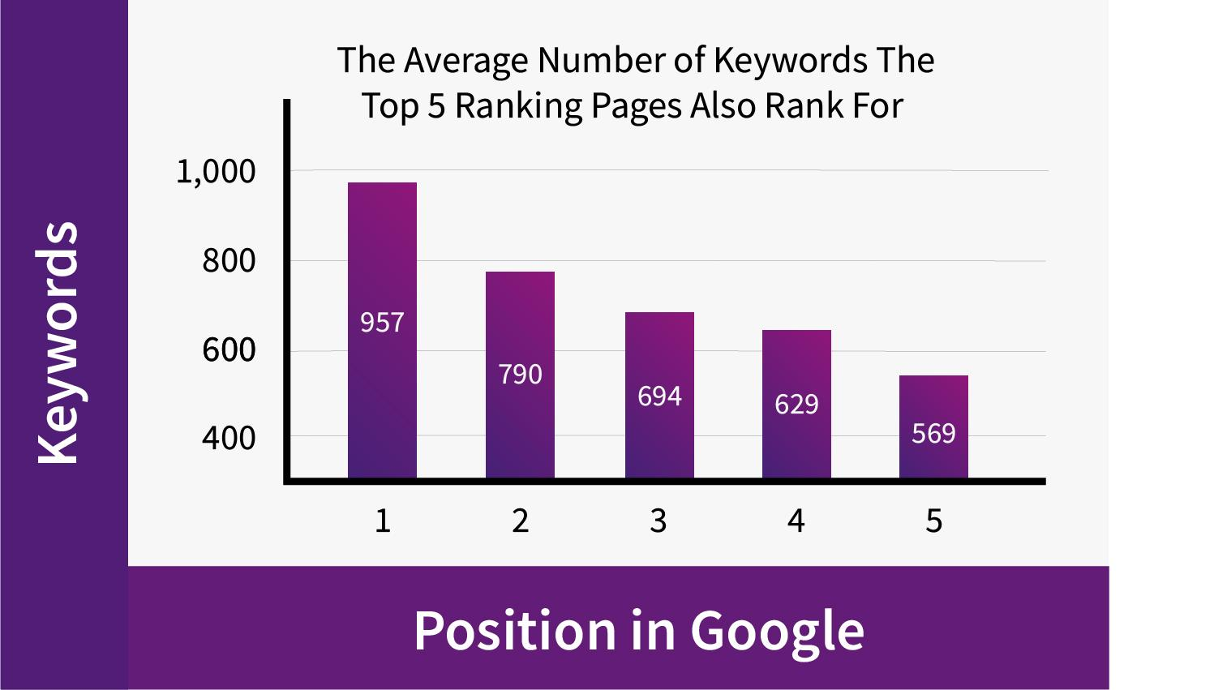
Abbildung 10 Keywords in Title Tags: How to find the right keywords

For example, let’s say your main keyword is ‘lead scoring’. One of your long-tail keywords could be ‘lead scoring examples’.

To include both of these, your title could look something like ‘Lead Scoring Examples to use in 2020’.

If you are struggling to find your keywords, our SEO team at Marketing Monkeys can help you with your keyword and competitor research.

2. Craft Basic Title
Don’t worry about the SEO techniques discussed in this stage, just simply write a title that describes your page content. From the above example, this could simply be: ‘5 Lead Scoring Examples’. This includes both the main and long-tail keyword but doesn’t really have any other SEO factors to it.

3. Apply the Factors in This Article
Now it’s time to apply the factors discussed in this article to give your title a little more ‘SEO juice’.

You could simply add in one of the popular phrases, add an emoji, include a call to action, or make it more eye-catchy by using different verbs and dates. If you really wanted, you could implement multiple SEO factors into one title.

Your newly improved SEO title would look something like:
Top 5 Lead Scoring Examples to Increase Conversion

How to Evaluate Your Titles

Once your title is live, the question then becomes: how do you know if it is working or not?

The main aspect used to measure how well optimized your title tags are is your CTR.

However, if your web page isn’t on the first page of search results, then it is worthless worrying about your CTR. As the famous saying in the SEO community goes: “the best place to hide a dead body is on the 2nd page on Google”. No one clicks past the first page.

If your web page isn’t on the first page, make sure your whole page is SEO optimized, following our guides on how to improve your pages SEO ranking.

Once your page is ranking in the first page, now you can worry about its CTR.

Your titles are the main factor which affect your clickthrough rate, after all, it is what readers are clicking to access your web page. To view your CTR, use Google’s Search Console. This software will show your page stats, including your CTR, clicks, and impressions.

Your pages that have a higher CTR generally means that they have better-optimized titles. If your page has significantly lower CTR than other articles, it means it is time to rewrite it.

This could be because you haven’t optimized your title tag for SEO properly, or because it isn’t as good as your competitors. Make sure you have followed the steps in this article to ensure your title is properly optimized. If it is, then try and reword it a little bit.

Use the same keywords but change some words around. Maybe add the year to the end or add one of the top 20 phrases mentioned earlier. The problem may be with the copywriting of your title. Look at what your competitors look like and think of how you can stand out from them.

If your CTR is still struggling, then reach out to one of our SEO experts who will be able to audit your title tags for you and advise on the best ways to improve your CTR.

Conclusion

Title tags are the make or break of how much traffic your web pages will gain. According to Moz, they are in fact the second most important on-page factor for SEO, behind content.
The correct optimized title tag can improve your CTR by 20%-100%, and generally, doubling your CTR will double your conversion rate. If you can master the title tag, then you will be getting a dramatic increase in traffic to your website, and ultimately, an increase in paying customers.

And the best bit, it is all organic. Being able to organically double your conversion rate is any company's dream, and by following the steps in this article, you will be on your way to achieving it.

Once you’ve created your title tags, we can test their SEO for you. Simply contact us, and we can see how well optimized your title tags are and provide you with advice to help improve your rank position, click through rate, and conversion rate.

